Name: Slobodan Kolaković
E-mail: kolakovic.s@uns.ac.rs
Institution: University of Novi Sad, Faculty of Technical Sciences
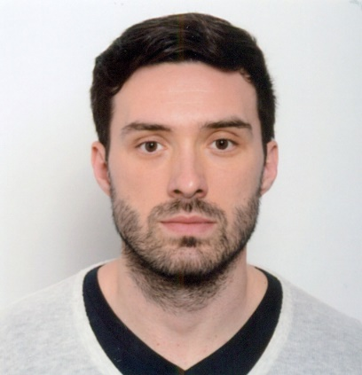 | Slobodan Kolaković has obtained his Bachelor and Master of Science degree in Civil Engineering at the Department of Water Engineering and Geodesy at the University of Novi Sad in 2011. He received his Ph.D. in Hydrotechnics Science from the University of Novi Sad in 2017. His research interests are flood risk, implementation of computer technology in flood protection and hydrotechnical structures. He is currently working as an Assistant professor in the Department of Civil Engineering (Center of Water Engineering and Geodesy). He teaches 5 courses in Undergraduate Academic Studies of Civil Engineering, Architecture, Disaster Risk Management and Fire Safety, Environmental Engineering and Geodesy and Geomatics: River regulation and flood protection, Water supply and sewer system in building, Climatology, Fundamentals of Water Protection and Basics of Civil Engineering. He also teaches 2 courses in Master Academic Studies of Civil Engineering: Hydrotechnical Structures and Traffic flow theory.
References (max. 5 relevant references)
- Knowledge For Resilient society
ERASMUS +, European Union (2016 - 2019)
Project: 573942-EPP-1-2016-1-RS-EPPKA2-CBHE-JP
- Flood Risk Management of the Republika Srpska: Rise Sava Dyke, Bijeljina
IPA European Union (2013)
Project: WB5-BIH-ENV-17_PC974.1
- Flood Risk Management of the Republika Srpska: Raising of Sava Dyke Level, Lokation PS Domuz Skela, Semberija
IPA European Union (2013)
Project: WB5-BIH-ENV-17_PC968
- Tisza River Modelling on the common interest section of Hungary and Serbia and developing of the measuring equipment-TRMODELL
IPA European Union (2011)
Project HU-SRB/0901/121/0
- Developening of hydroinformations system for drought monitoring
Ministry of Science/ Faculty of Technical Science
This project has been funded with support from the European Commission. This publication reflects the views only of the author, and the Commission cannot be held responsible for any use which may be made of the information contained therein.

